**Project Vis 2:**

**Nuclear, Weapon & Energy**

**Name:** Lee Jian Hui

**Tutor:** Dr. Ting Chai Wen

**Student ID:** 32116314

**Number of words:**  919 words

**URL:**

<https://lee-jian-hui.github.io/FIT3179-project-vis-2/code/index.html>

**b. A brief description of the domain, Why and Who.**

This visualization is designed to visualize the trends in nuclear energy and the dangers it poses to humankind. We are able to discover more suprising details regarding the adoption of nuclear technology.

This visualization caters to are people who are generally interested in trend on the topic of nuclear technology as well as draw attention on trends and important facts regarding the adoption of nuclear technology.

**c. What: A brief description of the data (sources, authors, relevance,**

**creation process, etc.).**

The datasets are mainly sourced from Kaggle. The Nuclear Reactor and frequency dataset (Palkova, 2018) details the distribution of nuclear reactors around the world and in different regions. It was briefly cleaned using Python Pandas, then used to create the choropleth map using cumulative frequencies of nuclear reactors.

Mortality Rate of Energy Sources (Roser) provides data from 2014, about mortality rate for each type of Energy source, per Twh.

Available nuclear warheads per country per year (Okhuijsen) details about the trend in nuclear stockpile for each country.

The 4th dataset (Roser), provides a full detailed overview about energy data. This is briefly cleaned to exclude unnecessary columns and data about energy consumption is used.

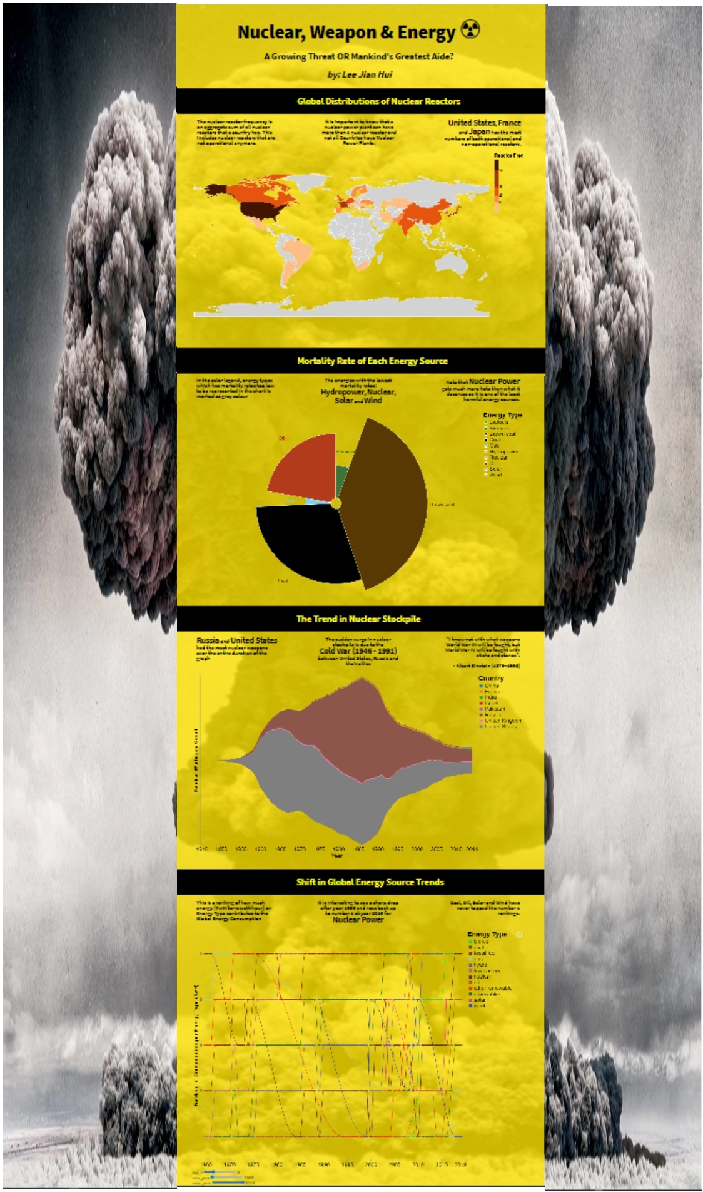

**d. Why and How**

* 1st Idiom (Choropleth Map)

It wasn’t optimal to use symbol maps, due to width of webpage being narrow, causing cluttering of data points, instead, a choropleth map was chosen.

I mainly want the users to visualize the number of reactors that a country has, in terms of non-operational ones as well.

This is not an up-to-date vis to visualize distribution of operational plants, but rather display the number of nuclear reactors each country has.

The color thresholds used also fits the theme.

* 2nd idiom (Radial Plot)

Area and angle encoding is a good fit visualize the approximate proportion when used to encode the share of energy consumption of each energy source.

Users can visualize Energy sources which contribute to the most Deaths per Twh of energy consumed.

We found out that brown coal has the highest mortality rate per Twh.

While the energy types that are shaded grey in the legends means that these are the energies which causes the least deaths.

Death goes hand-in-hand with some energy source production, for example, burning too much brown coal causes air pollution which can be fatal to patients with respiratory problems.

* 3rd idiom (Stream Graph)

We can visualize a sudden bump in the stream graph, which is exactly the interval for when the cold war between United States and Russia, started and ended.

Users are able to spot some pattern in terms of nuclear inventory, where a sudden surge during the cold war is observed, and now it is gradually thinning out.

* 4th idiom (Rank/Bump Chart)

Visualize the change in trend of the popularity of each type of energy’s primary energy consumption.

Primary energy consumption measures total domestic energy demand.

Users can use sliders to narrow down the top ranks and specific year interval that they want to visualize. When clicked on a point mark or on the legend, filters for a specific energy type.

**e. Design:**

Designed with symmetricity in mind, each container, below the subtitle, always contain one idiom, with 3 columns of body text.

The reading direction is a top-down direction, as users are forced to scroll down.

**ii. Colour:**

the colors for the visualization are inspired from the radioactive emoji, which is just yellow and black, so these are the main color schemes.

Accompanying colors to vary nominal attributes are also well-selected to match the overall pale yellow background color and the background image,

**iii. Figure-ground:**

Important text is boldened at different levels, dependent on text hierarchy, and also has larger text size, to show greater emphasis.

Subtitles have a black-color container that separates each idiom component and accompanying text from each other.

Text annotation with white color has great figure-ground with the darker colors of the streamgraph area mark for United States and Russia.

Radial plot’s legend has subtle figure-ground in the energy types that have a mortality rate too low to be measured, have a color label of grey, these are the most harmless energies in terms of mortality rate.

**iv. Typography:**

All of the text elements use sans-serif font, due to cleanliness and also due to the topic being of a scientific nature.

Title, subtitle and body text all use the same typeface, Source Sans Pro

Any text or labels that is bound to idioms use the built-in vega lite typeface as that seems to me, the most natural typeface for the vega-lite charts.

A text hierarchy is imposed by the boldening and variance in size of text, more notably, the important points in the body text is also boldened to highlight key facts.

**v. Storytelling:**

The scrollytelling principle is applied due to the layout of the visualization, so reading direction is top-down. The layout is as depicted earlier.

Subtitle and their respective containers gives a clear breakdown and separation of focus from the whole picture down to the finer details.

**f. Bibliography/list of references.**

Datasets:

🡪 Nuclear Reactor and frequency (1st idiom) (Palkova, 2018)

<https://www.kaggle.com/liananapalkova/nuclear-power-plants>

🡪 Mortality Rate of Energy Sources (2nd idiom) (Roser)

<https://ourworldindata.org/nuclear-energy>

🡪Available nuclear warheads per country per year (3rd idiom) (Okhuijsen)

<https://data.world/datagraver/nuclear-warheads-per-country>

🡪 Energy Data (Roser)

<https://github.com/owid/energy-data>

Others:

🡪Albert Einstein Quote

<https://simple.wikipedia.org/wiki/World_War_III#:~:text=Albert%20Einstein%20is%20often%20quoted,fought%20with%20sticks%20and%20stones%22>.

**g. Appendix (5DS)**

